# Air Quality Monitoring

## ****1.**** INTRODUCTION

* As our project is based on IoT, let us throw some light on the topic of IoT itself.
* The InternetofThings (IoT) is a system of interrelated computing devices, mechanical and digital machines, objects, animals, or people that are provided with unique identifiers (UIDs) and the ability to transfer data over a network without requiring human-to-human or human-to-computer interaction.

## 2. HARDWARE REQUIREMENTS:

* Air Quality sensor (MQ 135)
* Potentiometer
* 16x2 LCD Panel
* Arduino Uno
* Wires

## 3. SOFTWARE REQUIREMENTS:

* Arduino (Version 1.8.2)
* THINGSPEAK website

## 4. Design diagrams

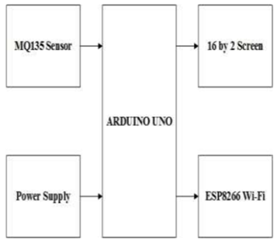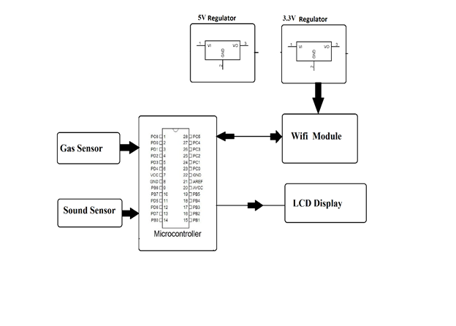

## ADVANTAGES:

* Sensors are easily available.
* Simple, compact, easy to handle.
* Sensors have long life and less cost.
* Quality of air can be checked indoor as well as outdoor.
* Detecting a wide range of physical parameters including temperature ,humidity and carbon dioxide.

## APPLICATIONS:

* Indoor air quality monitoring.
* Industrial perimeter monitoring.
* Roadside pollution monitoring.
* To make this data available to common man.

## CONCLUSION

Air quality monitoring systems are designed using different sensors for indoor and outdoor air quality monitoring in the previous works by using Bluetooth, GPS, GPRS wireless technologies. In a previous work WASP module is used which is costly. Instead of that different sensors can be used. The proposed system is developed for indoor air quality monitoring remotely. It is cost and energy efficient request and respond protocol is used along with combination of address and data centric protocols. Paper presents the summary of various techniques of air quality monitoring. These techniques are elaborately discussed in the paper. In the proposed system, one of the most preferred technique is cloud based air quality monitoring system. Using the same cloud data, website is hosted and data is displayed on the website.

## REFERENCES

[1] Poonam Paul, Ritik Gupta, Sanjana Tiwari, Ashutosh Sharma, “IoT based Air Pollution Monitoring System with Arduino”, IJART, May 2005.

[2] Zishan Khan, Abbas Ali, Moin Moghal, ”IoT based Air Pollution using NodeMCU and Thingspeak”, IRANS, pp. 11-16, March 2014.

[3] SaiKumar, M. Reji, P.C. KishoreRaja ”AirQuality Index in India”, IEEE conference Chennai, August 2014.

[4] Mohan Joshi, ”Research Paper on IoT based Air and Sound Pollution monitoring system”, IETS Journal, pp. 11-17, September 2015.

[5] ”Malaya Ranjan, Rai kumar, ”Understanding Parts per million in real time air quality index”, Journal of Mathematics and advanced sciences, pp. 23-29, September 2009